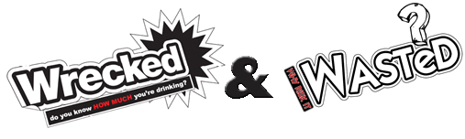
After an online competition, two rounds of heats, the Wrecked & Wasted Battle of the Bands 2012 final went down a storm!
Four local bands Draw Me A Promise, PlayDead, Spoken Silence and Bound To Burn battled it out to see who would be crowned the winners for 2012.
The big event took place on Fri 30th November at Cheers Nightclub, Dumbarton.
Over 180 gig goers invaded the West Dunbartonshire Battle of the Bands 2012 to support the Wrecked & Wasted campaign and to cheer their favourite bands.
The event has been organised as part of the local Wrecked & Wasted campaign to raise awareness of the risks of drinking alcohol and dangers of substance misuse amongst young people in West Dunbartonshire.
The crowd enjoyed sets played by each of the finalist bands before top band Scottish band Hip Parade took to the stage whilst the panel of judges collaborated scores and debated a winner.
Hip Parade, who have previously played T in the Park and toured with top band Stereophonics, were involved in previous Battle of the Bands Heats as talented members of our judging panel.
After a lengthy discussion within the judging panel PLAYDEAD were crowned Wrecked & Wasted Battle of the Bands Winners 2012. Top judge on the evening, Jim Gellatly, Clyde 1 Radio presenter announced “I have been really impressed with quality of the bands performances tonight – each of the bands are well deserved finalists and Playdead worthy winners of this year’s competition.”
Carinna McMillan, O2 Senior Operations Manager, Think Big stated “We are delighted to support the West Dunbartonshire Wrecked & Wasted Initiative and prizes for this years Battle of the Bands. We have managed to attract an array of talent for the judging panel for this event, including Jim Gellatly (Clyde 1), Ally Grey (Emu Bands), Robert Brogan (New Rhythms) and Phil Plunkett (Lomond Studios). Sonar FM also helped broadcast the final live to listeners across Glasgow. New Rhythms Recording Studio kindly donated the top prize for the winning band, to record professionally at their recording studio.”
Laura Ward, Y sort it Senior Youth Worker also stated “This was a fantastic opportunity not only for West Dunbartonshire bands to showcase local talent, but a very effective way of engaging with local young people about the responsible drinking and promote messages about the risks of substance misuse. 480 young people in total, have attended Wrecked & Wasted Battle of the Bands events this year, not only have these events been a great opportunity to celebrate local music but for local young people enjoy a safe night out.”
For more information about the Wrecked & Wasted Campaign or future events please visit www.wreckedwd.co.uk or contact Y sort it on 0141 941 3308.

